**The Regional Landscape of Social Investment in the UK**

*Cite as: Nadeen Purna, Dr Lauren Tuckerman, Dr Syahirah Abdul Rahman and Professor Tim Vorley. 2023. The Regional Landscape of Social Investment in the UK: Comparison between England & Scotland to Identify Gaps and Opportunities for Supporting Social Enterprises Case Study. Oxford, UK: Innovation Caucus.*

# Project Summary

The *Social Investment Project* builds on the findings of the *Social Investment Partnership* project and the *Commercialisation of Social Sciences (CROSS)* project to extend insights on understanding the regional landscape of social investment practice and policy in the UK. It does so by comparing the social investment landscape between England and Scotland to identify gaps and opportunities in these regions regarding social investment support to obtain actionable insights for the ESRC and Innovate UK. The key findings are summarised as follows:

* Social enterprises often lack investment readiness to take on social investment. This lack is primarily shaped by social enterprises’ risk aversion towards investment capital, difficulty managing and measuring social impact while generating financial returns, and limitations with profit distribution.
* Investors also lack awareness of how to support early-stage social enterprises who struggle to meet stringent investment conditions. As a result, social investment is moving away from the third sector.
* An acute gap in knowledge and awareness is present among both social investors and social enterprises related to each other’s work. This gap extends to social investors’ awareness about spin-out ventures out of social science research.

Evidence shows knowledge gaps further affect the uptake of relevant policy support.

* There are several divergences between Scotland and England’s social investment policy and practice, which suggests two distinct ecosystems have evolved in the two countries. Scotland shows higher engagement and integration among its various stakeholders. It has more dedicated policy support for social enterprises and investment. England represents a rather dispersed ecosystem with lack of clarity in its policy direction.
* These gaps have created opportunities for enhancing support for social enterprises including: de-risking social investment, creating opportunities for networking and knowledge exchange among social investors and enterprises, encouraging mindset change in investors, pooling resources across enterprise incubators in universities, and taking country or region-specific approach to policy advocacy and resource mobilisation and distribution. In this report we outline our methodology, share some preliminary findings and share a summary of opportunities to support social investment.

# Methodology

The findings of this study are based on data collected via in-depth semi-structured interviews with organisational social investors or social investment intermediaries, social enterprises, university enterprise incubators supporting CROSS, and policymakers. 14 interviews have been conducted and analysed thematically. In this report, CROSS refers to spinout ventures from social science research.

# Findings

**3.1 Investment readiness of social enterprises**

Based on Mason and Harrison’s[1] (2001, p. 664) three dimensions of ‘investment readiness’ (entrepreneur’s attitude towards finance, investability of the project/enterprise, and shortcomings with presentation), we assessed if social enterprises including research spinout ventures are considered investment ready. The majority of respondents confirmed that there are several shortcomings in potential recipients of social investment that limit their investment readiness (see Figure 1).

The most common view was that social sector organisations are risk averse which inhibits their engagement with social investment. Interestingly, the inhibition is higher towards debt capital as attitudes towards equity investment are mainly shaped by restrictions in legal forms or industry codes. As a result, some social investors expressed frustrations due to the limitations caused by the Community Interest Company (CIC) legal structure (which allows a limited share issue). The legal form was felt by interviewees to be especially limiting for a start-up, even though it has been created to support social enterprises and limit investor’s influence in the enterprise. This limitation with taking on equity investment is more prevalent in Scotland than in England where enterprises have been reported by interviewees to have higher appetite for taking on equity.

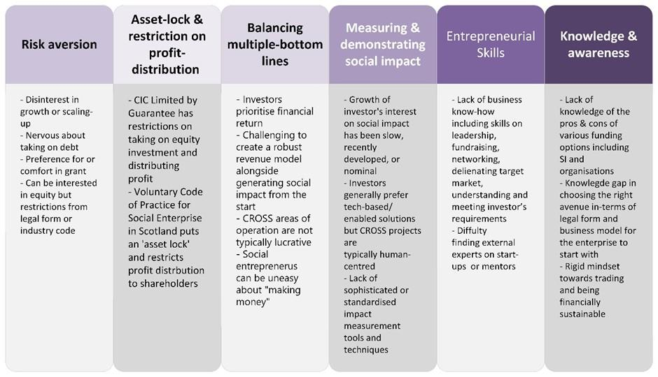

Figure 1: Investment readiness of social sector organisations

In-terms of investability, social enterprises commonly struggle with the demanding task of balancing multiple-bottom lines, i.e., devising a robust revenue model and simultaneously, generating social impact. One respondent highlighted the gravity of this balancing task specifically for commercialisation of research taking on the social enterprise route.

“You [social enterprise] tend to be working in areas where there's less money floating around, the customers can't pay as much; you might have to have multiple sources of funding to stay sustainable”.

Social enterprise start-ups, thus, at one end struggle to attain financial sustainability, which necessitates external funding; however, its limited profitability makes the venture less attractive to external funders. The investors’ proclivity towards financial returns with limited attention to social impact also contrasts social enterprises’ crux of addressing social needs and generating long-term impact. While dedicated social investors have mentioned having built-in impact assessment in their investment screening, the mechanisms can lack sophistication, by their own account. Most respondents have highlighted the available methods are not standardised or able to capture the complexities of long-term qualitative social impact; thus, evaluating social impact has been described as a “huge challenge” and the methods a “complete mess”. This can partially explain investors’ disinterest in social impact.

## Investor readiness to provide social investment

Participants have highlighted the risk aversion in investors regarding investing in early-stage ventures addressing social goals. This includes both dedicated social investors and mainstream private investors who require the applicant to have a few years of trading history to gain confidence, which early-stage ventures would lack. A growing trend in the social investment sector is investment in property as opposed to investment in social sector organisations. This trend has been reflected in the Big Society Capital’s Market Sizing data (2022)[2] and is particularly evident in England. Both a social investor and a former policy maker attributed this trend to the ease and safety of investment into social property funds that provide more assured returns due to steady demand for housing. However, this is a concerning trend for social sector organisations as property is a small proportion of the overall sector, which tends to be service based.

## Knowledge and awareness of social investment and enterprise

While some gaps in knowledge and awareness of social investment and social enterprise were predictable, the lack of understanding of social enterprise models by investors was highlighted by several respondents as being particularly challenging. Respondents have emphasised that investors often fail to comprehend the specificities of social enterprises or their legal forms. One respondent highlighted that small and medium-sized funders, in particular, struggle with the idea that social enterprises can make money while addressing a social need. This is surprising given the UK is considered to have one of the most supportive environments for social enterprises. More specifically related to commercialisation activities coming out of academic research, we have observed a gap in awareness of it among social investors. Their views on university partnerships are limited to the researcher’s role as evidence-builder or universities as facilitators of knowledge transfer and community engagement.

Another salient point on this theme relates to the social investment tax relief (SITR). Mixed views emerged on its efficacy, but there was higher agreement attributing its limited uptake to firstly, a lack of awareness about SITR and secondly, poor comprehension of the complex legislation. Thus, poor mobilisation of information risks continuity of potentially useful policy levers, as seen with the impending withdrawal of the SITR.

## Variations in Scotland and England’s Social Investment ecosystem

Our study affirms our preliminary view that England and Scotland can be regarded as having two varying social investment ecosystems owing to their cultural, political, and regulatory distinctions. Similar to an entrepreneurial ecosystem, the social investment landscape shows patterns of having complementary yet diverse entities working jointly towards creating economic and social value. One of the central actors of this UK-wide ecosystem is the Big Society Capital (BSC). However, all groups of respondents expressed grievance with BSC citing that it has become increasingly commercially minded. Its investments are driven towards non-risky and high-yield areas like property instead of providing early-stage and small-sized funds. However, since BSC is reported to have limited footprint in Scotland, the impact of its commercial mindedness is likely to be felt more acutely in England. Multiple respondents have suggested that key industry bodies and funders in England like Social

Enterprise UK, Access, Nesta lack in close partnership to give the sector coherent guidance.

There was stronger evidence to suggest more collaboration between Scottish social investment intermediaries, the industry bodies like Social Enterprise Scotland, universities, as well as the Scottish government. According to most respondents, Scotland's community driven culture contributes to the sector’s collaborative approach. However, in the context of commercialisation of social science research, one respondent from a university enterprise incubator highlighted that a section, albeit minor, of social investors are trying to lobby the government to restrict universities’ ability to take on equity stake in social enterprise spinouts from universities since it curbs their share. On a similar vein, one social enterprise respondent, who runs social entrepreneurship training programmes, called for prevention of service duplication in the Scottish social investment space. The respondent witnessed their social investment funder foray into a similar area as ancillary service provision.

### England and Scotland’s divergent social investment regulatory environment

The distinction between England and Scotland’s social investment ecosystem can largely be attributed to the distinct regulatory environment in the two countries. The major distinctions which most respondents across the board reported are summarised in Table

(1).

**Table 1: Difference between social investment regulatory environments in England and Scotland**

| **England** | **Scotland** |
| --- | --- |
| Weak integration among social investment stakeholders | Coherent and integrated ecosystem |
| UK Government currently lacks social investment or social enterprise policy direction | Social investment and social enterprise efforts integrated within the Scottish Government policies including Social Enterprise Strategy,  Wellbeing agenda, National Strategy for  Economic Transformation |
| Policymakers are inaccessible; lack of clarity on the departments responsible for social investment | Respondents feel listened to and have been consulted with by the Scottish Government.  Policymakers are easily accessible. |
| The UK government retains some efforts that are conducive to building the social investment market, like providing social investment funds; but the future of such efforts remains uncertain. The turbulent policy environment means that social missions are often left by the wayside (for example seeing Healthy Ageing become merged with a broader 'Healthy Living' agenda) | The government has mobilised industry bodies like SENScot and Social Enterprise UK, which have been merged to create a single touchpoint for social enterprise support. It has also regularly partnered with local social investment intermediaries to disburse funds |

Although Scotland fares well compared to England in policy support and having a supportive social investment ecosystem, there is still room for improvement in providing long-term or patient funds and providing growth capital. Interestingly, several respondents have reported they found certain local authorities in England supportive and enthusiastic about social investment and social enterprises. Thus, a few social investors have reportedly taken a place-based approach to social investment. However, unpacking the depth and synergies of place-basis of those localised social investment was beyond the scope of this study.

# 4. Opportunities

* **De-risking social investment** with alternative arrangement of finance like blended finance (for example, the *Healthy Ageing* Investment Partnership’s grant-equity mix), small-sized trial loans, repayable grants, community shares, or revenue-based payment methods to ease social enterprises into social investment and build their investment readiness for larger investment sizes.
* Creating tangible means of connecting potential investors with social enterprises by **organising networking opportunities**. This can mitigate the distance between the parties by encouraging knowledge-sharing and co-learning.
* **Providing training & mentorship** support for potential social investment recipients especially with refining their business model, on various legal forms, and funding avenues, etc. This also includes mainstreaming guidance on transitioning to social enterprises further down the line upon stabilising the revenue model. This can help the venture appeal to a wider base of investors in its early stage.
  + Several social enterprises and social investors run capacity-building training programmes which can be leveraged via collaboration.
* **Promoting and optimising resource pooling among enterprise incubators** in universities as they have reported benefiting from it. This can include sharing investor pools, knowledge-sharing by upskilling technology transfer offices about the social enterprise model to coach potential spinout ventures, sharing links of industry mentors etc. It can be a cost-effective way to create synergies among university enterprise incubators across UK universities.
* **Encouraging a mindset change in investors** towards understanding the social impact of especially small & low-capacity ventures. Not all social enterprises will aim to be high growth-focused, but that does not negate their social impact. Singularly focusing on mobilising investment readiness without encouraging changes on the investor’s end can marketise social ventures while eroding their social impact dimension.
  + For CROSS, this change can be facilitated by building an evidence base of case studies on such spinouts’ social impact over the years. This can provide both social and traditional investors with confidence to support such initiatives.
* **Engaging in country or region-specific policy advocacy** and resource mobilisation to leverage the benefits of the respective ecosystems. Social investment and enterprise policy support is presently germane in Scotland. This makes Scotland a fertile ground for calling for further support with seed and growth capital and investment readiness support from the Scottish Government. Scotland’s integrated ecosystem can be leveraged to build investment partnerships. Simultaneously, provision of more early-stage resources and small-sized fund support can be concentrated in England where a weak social investment ecosystem is reported.
  + Certain regions in England have been remarked as having a higher appetite for social enterprise and social investment. This can be further explored to identify the determinants of success and prospects of transposing those models.

**Authors**

Nadeen Purna (Innovation Caucus, Oxford Brookes University)

Dr Syahirah Abdul Rahman (Innovation Caucus, Oxford Brookes University)

Dr Lauren Tuckerman (Innovation Caucus, Oxford Brookes University)

Professor Tim Vorley (Innovation Caucus, Oxford Brookes University)

**Research note**

This research is a case study prepared as part of the work Innovation Caucus conducted in partnership with Innovate UK (IUK) and the Economic and Social Research Council (ESRC). If you have any questions relating to this report please contact info@innovationcaucus.

**Acknowledgements**

This research was commissioned by IUK and ESRC. We are very grateful to the project sponsors at both IUK and ESRC for their input into this research. The interpretations and opinions within this report are those of the authors and may not reflect the policy positions of IUK or ESRC.

**About the Innovation Caucus**

The Innovation Caucus supports sustainable innovation-led growth by promoting engagement between the social sciences and the innovation ecosystem. Our members are leading academics from across the social science community, who are engaged in different aspects of innovation research. We connect the social sciences, Innovate UK and the Economic and Social Research Council (ESRC), by providing research insights to inform policy and practice. Professor Tim Vorley is the Academic Lead. The initiative is funded and co-developed by the ESRC and Innovate UK, part of UK Research and Innovation (UKRI). The support of the funders is acknowledged. The views expressed in this piece are those of the authors and do not necessarily represent those of the funders.

1. Mason, C.M. and Harrison, R.T., 2001. 'Investment readiness': A critique of government proposals to increase the demand for venture capital. *Regional studies*, *35*(7), pp.663-668.
2. https://bigsocietycapital.com/our-approach/market-data/